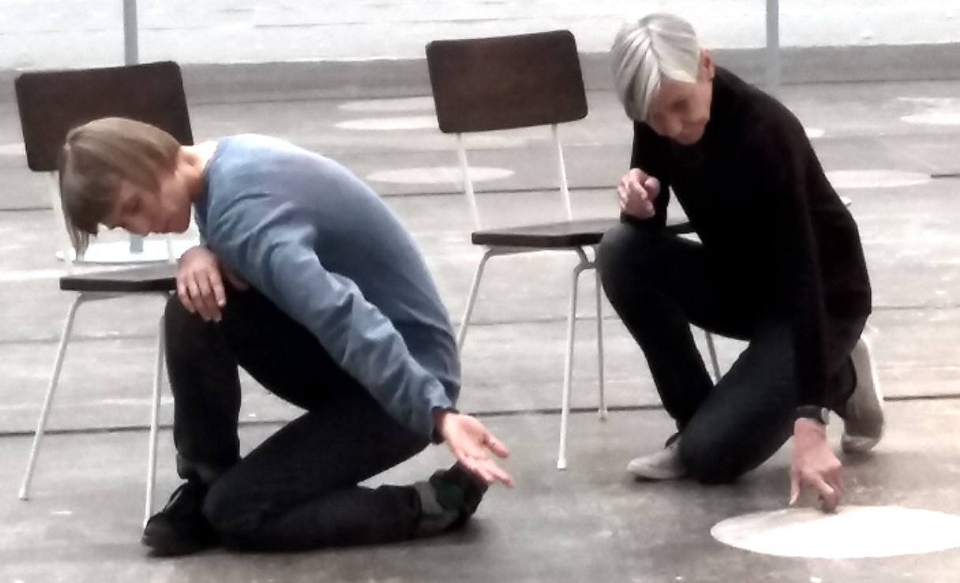
The Natural Grace of Mindful Movement
led by Ratnadevi
Saturday 18 Nov 2017, at In the Moment Centre, Glasgow
10 am – 1pm for anyone with a mindfulness practice, £30 (apply for conc.)
10am – 5pm for mindfulness teachers who seek to develop their mindful movement teaching repertoire and skill, £58 (apply for conc.)

This workshop focuses on allowing movement to evolve in a way that feels natural, authentic and deeply enjoyable. Within led sequences derived from Yoga and Feldenkrais Method, participants will be encouraged to let go of ‘right and wrong’ and trust the body’s innate wisdom.

The morning session will be led by Ratnadevi and will include some sitting meditation, poetry and verbal enquiry, aiming for a balanced and enriching experience.

The afternoon session offers a rare CPD opportunity for mindfulness teachers and trainee teachers to re-visit some of the principles underlying the teaching of mindful movement. There will be small group practice opportunities with feed-back and discussion. CPD certificate available on request.

Make a whole weekend of it and book also for Mindful and Nourishing Communication, Sunday 18 Nov 10am -5pm, at In The Moment Centre, £95 for both days, saving £21
Ratnadevi (Dr Luise Holtbernd) has been practising yoga and meditation for over 35 years and has been teaching courses, workshops and retreats in Scotland and internationally over the last 30 years. She has been offering MBCT/ MBSR courses since 2005, is a certified transformational coach and has extensive experience in training and supervising mindfulness teachers. She also has a PhD in the creative arts which informs her fluid and clear teaching style.
More info on www.livingmindfulness.net
Contact info@livingmindfulness.net

Booking Form
Please book me a place on (please delete as required):

The Natural Grace of Mindful Movement, Sat 18 Nov 17
morning only (£30), whole day £58)

Mindful and Nourishing Communication, Sun 19 Nov 17 (£58)

Both days (£95)

I require a CPD certificate

Name:
Email:
Tel:
I have made payment/ enclose cheque for

You can pay by BAC
Luise Holtbernd, 83-21-37, 00172480
Or send a cheque, made out to L Holtbernd to
Ratnadevi
2/1 14 Garrioch Drive
Glasgow G20 8RS

