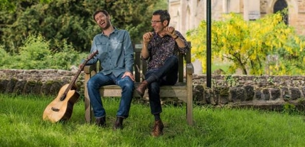
Mindful and Nourishing Communication
day workshop with Ratnadevi
Sunday 18 Nov 10am -5pm, at In The Moment Centre, Glasgow,
Fee: £58 (concession available on request)
This workshop is open to mindfulness practitioners who seek to communicate more effectively and compassionately in their personal and professional lives. For mindfulness teachers it could further develop and expand your enquiry skills and enhance your MBSR teaching repertoire. A CPD certificate is offered on request.
Communication is one of the most important and challenging mindfulness practices. It is in communication with others that the ability to stay present and non-reactive is most tested – and where automatic and reactive habits can prevent open and authentic connection. We might long for harmony, mutual respect, understanding and fun, but when faced with conflict, it’s easy to find ourselves tensing up and getting into a defensive mode that can be hard to shift. Unchecked, the difficult feelings and thoughts fester in the mind and can lead to low mood and depression.
The workshop offers structured explorations allowing us to become more versatile and skilled in connecting with ourselves and others. We recognise what is going on emotionally and do our best to allow it. From there we enter into a kindly exploration of what needs are not met for oneself and others. This leads to greater empathy and choice, and can be experienced as a deeply nourishing, connecting and freeing shift of perspective.
The day combines mindfulness practice with teachings based on Non-Violent or Compassionate Communication (Marshall Rosenberg) to provide a framework for playfully exploring mindful and nourishing communication.
Make a whole weekend of it and come to this one too, for only £95 for both, saving £21: The Natural Grace of Mindful Movement Saturday 18 Nov 2017, at In the Moment Centre, 10 am – 1pm for anyone with a mindfulness practice, £30; 10am – 5pm for mindfulness teachers who seek to develop their mindful movement teaching repertoire and skill, £58
Ratnadevi (Dr Luise Holtbernd) has been practising meditation for over 35 years and has been teaching both meditation and yoga in Scotland and internationally over the last 30 years. She has been offering MBCT/ MBSR courses since 2005, is a certified transformational coach and has extensive experience in training and supervising mindfulness teachers. She is involved in a research project combining MBCT and NVC. She also has a PhD in the creative arts which informs her fluid teaching style.
More info on www.livingmindfulness.net

Booking Form
Please book me a place on (please delete as required):

Mindful and Nourishing Communication, Sun 19 Nov 17 (£58)

The Natural Grace of Mindful Movement, Sat 18 Nov 17
morning only (£30), whole day (£58)

Both days (£95)

I require a CPD certificate

Name:
Email:
Tel:
I have made payment/ enclose cheque for

You can pay by BAC
Luise Holtbernd, 83-21-37, 00172480
Or send a cheque, made out to L Holtbernd to
Ratnadevi
2/1 14 Garrioch Drive
Glasgow G20 8RS

